
FAQ – Work From Home
Last Updated: 9th April 2020/Ver 1.5

Document REVISION HISTORY

Version  # | Created / Revised By | Reviewed By | Reviewed date | Approved  By | Approval  Date | Description of changes
1.0 | Infra Team | Madhavan.GG | 9th April 2020

Table of Contents
1 Zoom links for raising issues to Infra Team 5
1.1 Chennai Zoom bridge link 5
1.2 CBE Zoom bridge link 5
1.3 Pune Zoom bridge link 5
1.4 Manila Zoom bridge link 5
1.5 Mumbai Zoom bridge link 5
2 How to raise ticket to infra using mobile App 6
2.1 Steps embedded in the video given below 6
3 How to set up your computer 7
3.1 How to set up your computer at home 7
3.2 How to connect VPN while logging in 7
4 How to configure soft phone. 8
4.1 Configuration step as follows 8
5 How to configure soft phone in mobile 10
5.1 Configuration step as follows 10
6 Scenario - Forticlient vpn not found 12
6.1 Forticlient Vpn not found 12
6.2 Fix to be provided 12
7 Scenario - Dongle not detected 13
7.1 Dongle not detected 13
7.2 Fix to be provided 13
8 Scenario - Dongle device drivers update 20
8.1 Dongle device not detected because of driver issue. 20
8.2 Fix to be provided 20
9 Scenario - Error code (-5029) 24
9.1 Unable to connect SSL VPN with error popup 24
9.2 Fix to be provided 25
10 Scenario - Choppy Website Access Issues 26
10.1 Choppy Website Access Issues Like ARC, Client Websites, Reference websites 26
10.2 Fix to be provided 26
10.3 Connection failure 27
10.4 Fix to be provided 27
11 Scenario - Desktop icons not loaded 28
11.1 Desktop icons not loaded after login 28
11.2 Fix to be provided 29
12 Scenario - File path not opening 31
12.1 File path not opening even using the desktop icon 31
12.2 Fix to be provided 31
13 Scenario - Client application not working 33
13.1 Client application not working but arc is working 33
13.2 Fix to be provided 33
14 Scenario - Athena offline not working 34
14.1 Athena offline not working 34
14.2 Fix to be provided 34
15 How to do Speed test 37

Zoom links for raising issues to Infra Team

Chennai Zoom bridge link
https://zoom.us/j/179460553

CBE Zoom bridge link
https://zoom.us/j/954390310

Pune Zoom bridge link
https://zoom.us/j/716182990

Manila Zoom bridge link
https://zoom.us/j/533476081

Mumbai Zoom bridge link
https://zoom.us/j/962740959

How to raise ticket to infra using mobile App

Steps embedded in the video given below

How to set up your computer

How to set up your computer at home
Kindly follow the step provided in the below youtube video to set up your computer at home.

https://www.youtube.com/watch?v=wnGdAYV9MmU

How to connect VPN while logging in
Kindly follow the step provided in the below youtube video to login using VPN.

https://www.youtube.com/watch?v=wIHszGMAmb4&t=14s

How to configure soft phone.

Configuration step as follows
1.Open Microsip and select menu as highlighted below:
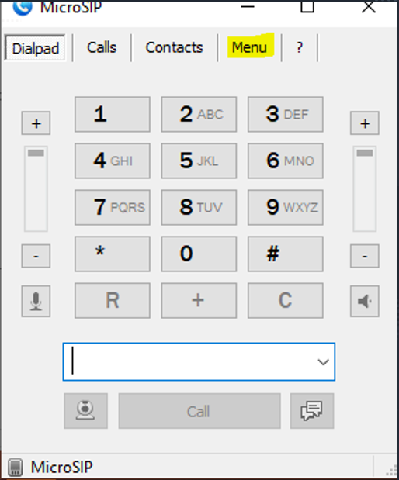

2. Select Add Account…
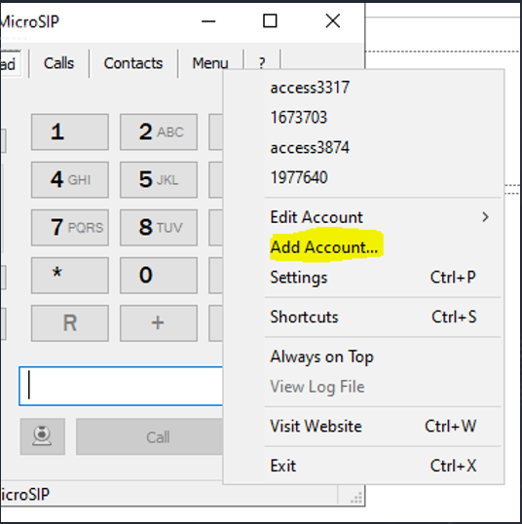

3. To configure an extension you would need to have the below details:
a. Number
b. Password
c. Domain

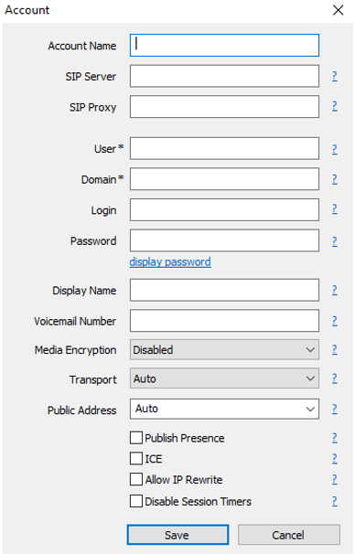

4. Sample extension configuration shown below:

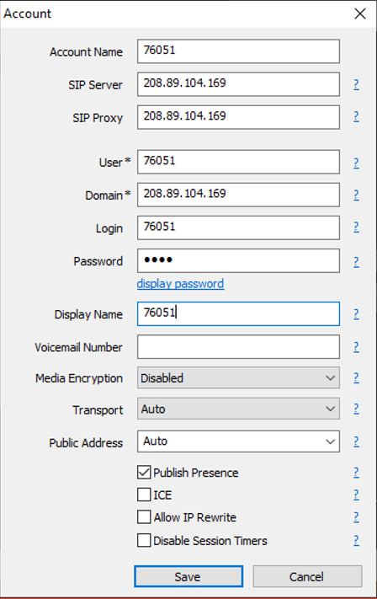

How to configure soft phone in mobile

Configuration step as follows
1.Goto play store and install Zoiper IAX SIP VOIP Softphone

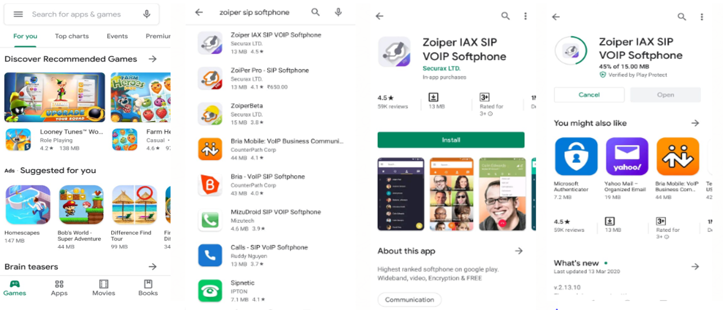

2.Account Configuration
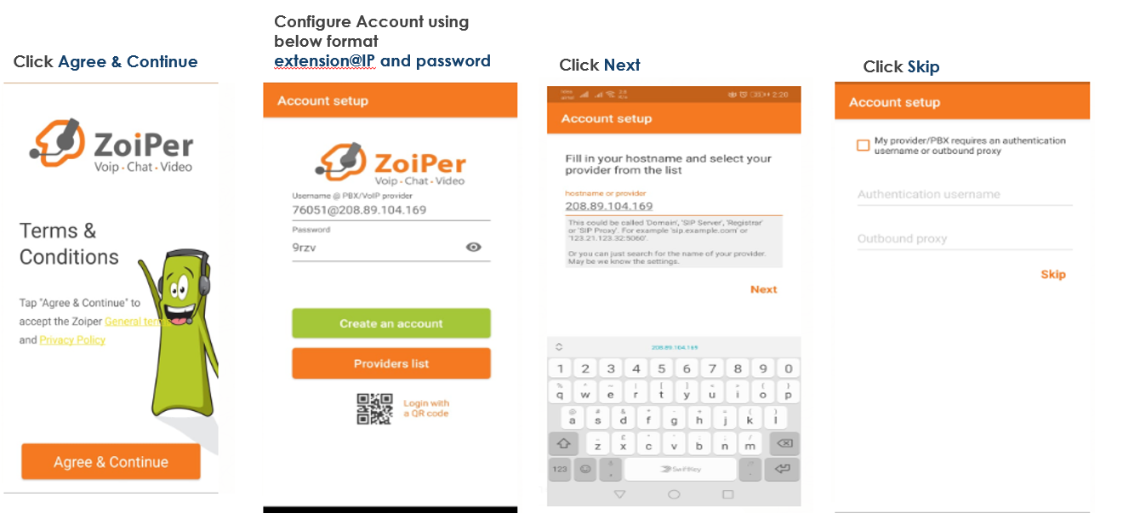

3. Account Configuration continues below
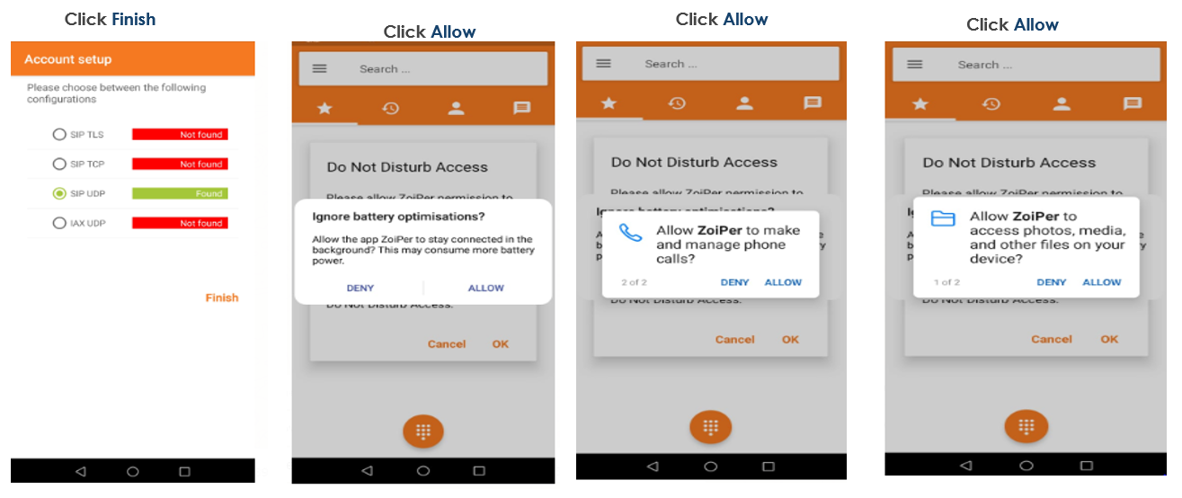

Scenario - Forticlient vpn not found

Forticlient Vpn not found
If you didn’t find the FortiClient VPN application in the system there will be no icon while login or in icons tray next to date.

Fix to be provided
Go to the below website and download the respective forticlient vpn and install.
https://ahsfileshare.z30.web.core.windows.net/
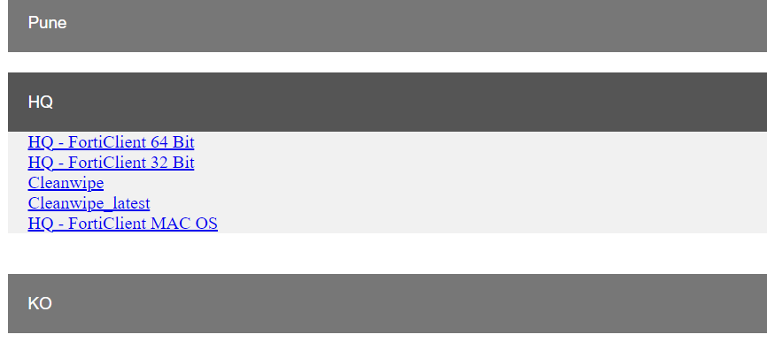

Scenario - Dongle not detected

Dongle not detected
If the dongle provided by AHS is not detected by the system and internet not working.

Fix to be provided
Method 1:
1. Need to change the dongle cable and check with user mobile USB cable.
2. Try to connect mobile by enabling the mobile data and USB tethering option in mobile settings.

If the above 2 steps failed Please follow Method 2 for uninstalling Symantec.
Method 2:
1. Hold Shift button and click Restart option.
2. Now you will be seeing the below screen, choose Troubleshoot Option
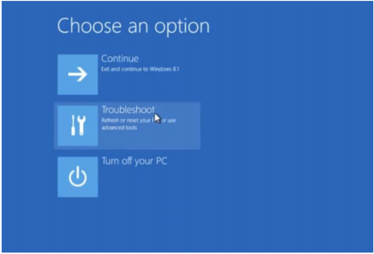

3. In next screen, choose Advanced Options
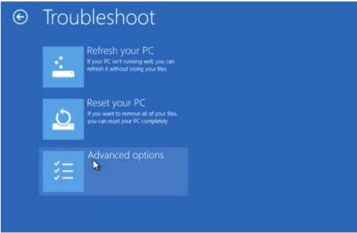

4. In next screen, choose Startup Settings
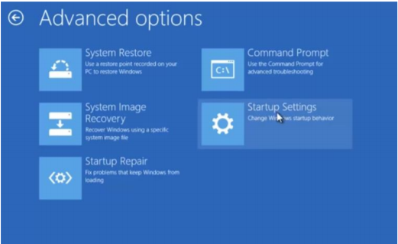
5. choose Restart option
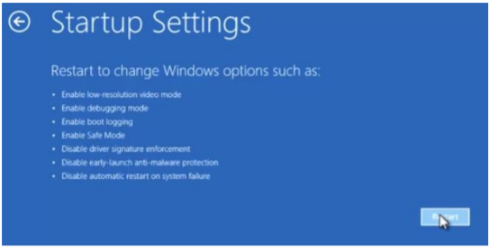
6. After restarting it will show the below screen, press 5 or F5 for choosing safe mode with networking.
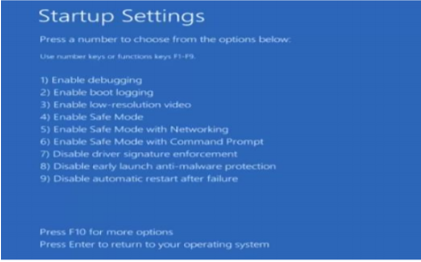
7. After the above step, In login screen enter ahsadmin/ahswfh credentials and login 8. After login into admin now reconnect the dongle or mobile by following method 1 - point 2 and wait for few seconds internet will be connected.
9. Now open chrome or any browser and enter the below link https://ahsfileshare.z30.web.core.windows.net/
10. Once the link is loaded you will be seeing the page like the below screen, Click HQ and select cleanwipe_latest
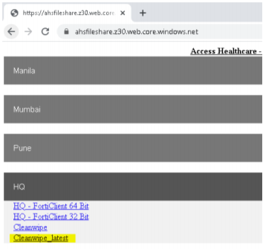
11. After clicking the cleanwipe_latest option, open new tab and check whether the file is downloading.
12. Once downloaded, open the application and double click the Cleanwipe.exe file.

13. After that it will pops up and asks for extract all, click extract all and run the cleanwipe.exe.
14. You will be seeing the below screen. Click Next
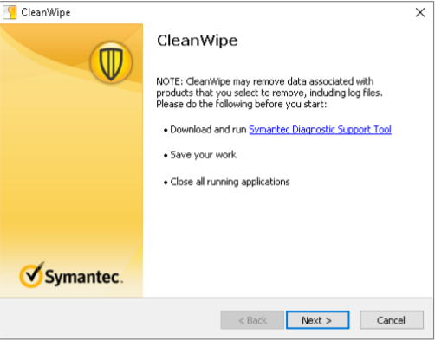
15. Check the highlighted box below and click Next
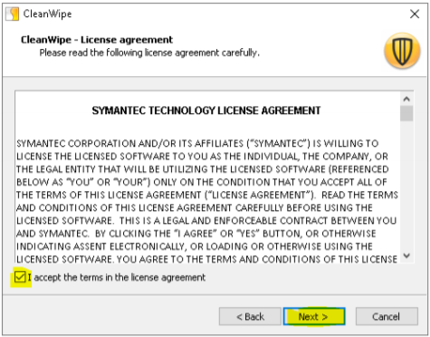

16. Now check all the 3 boxes and click Next
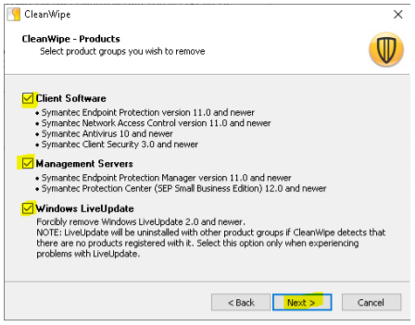
17. Now click next for the below screen
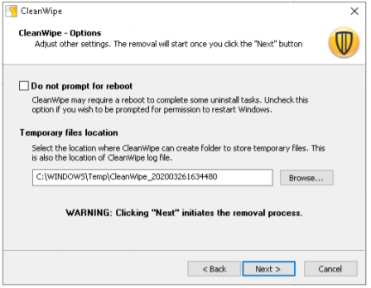

18. After clicking next it will show like below screen.

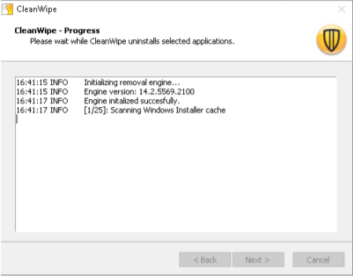

19. Once it completes click finish and then Restart.

Scenario - Dongle device drivers update

Dongle device not detected because of driver issue.
If you observe dongle is not detected and driver is not updated.

Fix to be provided
1. Login into local computer and search device manager
2. Device Manager Window
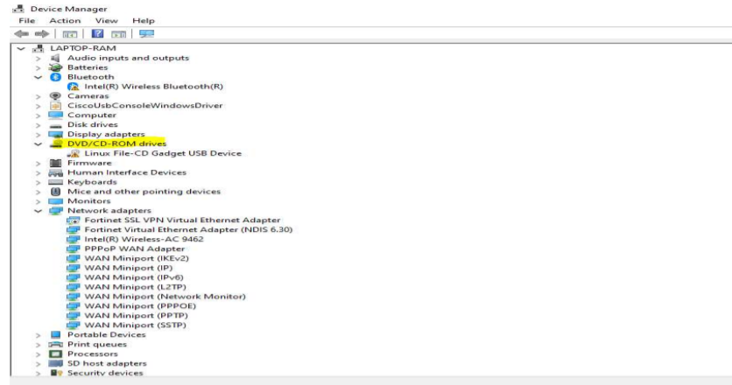
3. Right click the device under DVD/CD-ROM
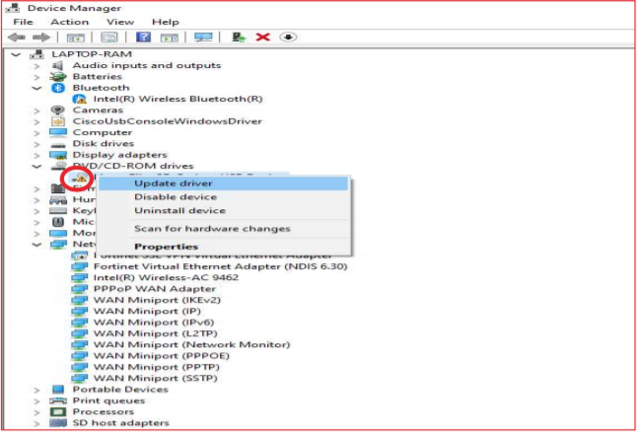
4. Select the Browse My computer for Driver Software
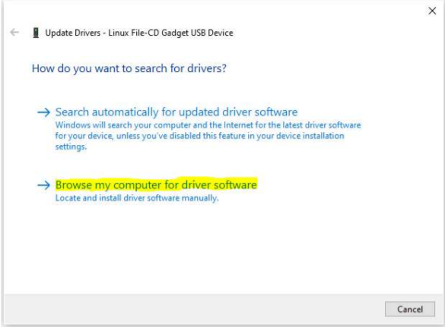

5. Choose Let me pick from a list
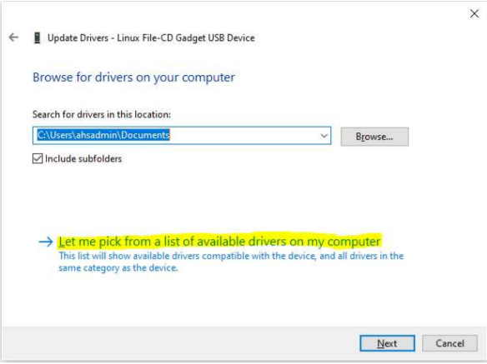
6. Choose Next button
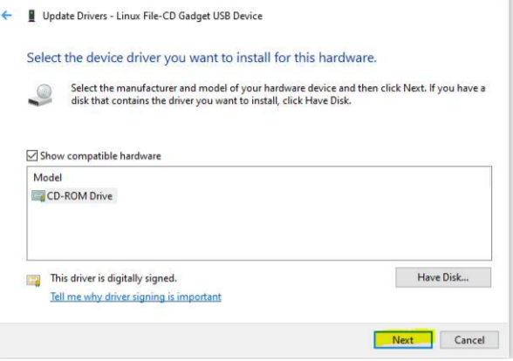
7. Driver will updated
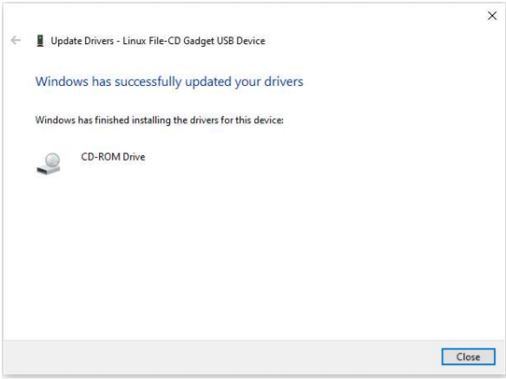

Scenario - Error code (-5029)

Unable to connect SSL VPN with error popup
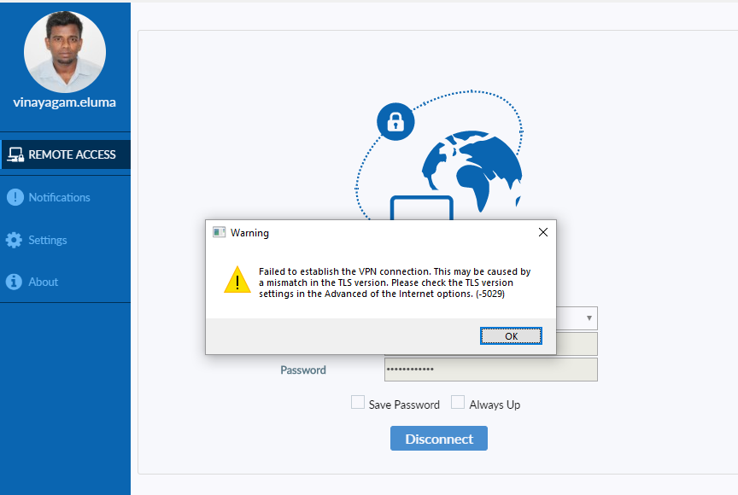

Fix to be provided

Enable ‘Use TLS 1.0’ ‘Use TLS 1.1’ ‘Use TLS 1.2’ in Internet explorer settings.

Before After
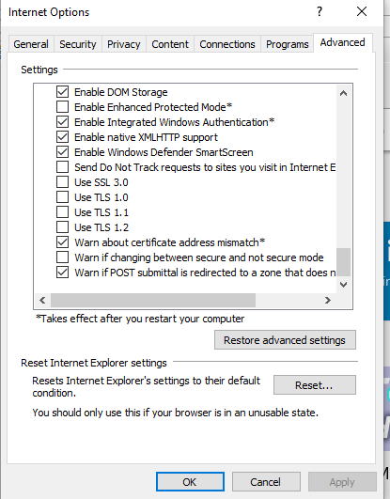
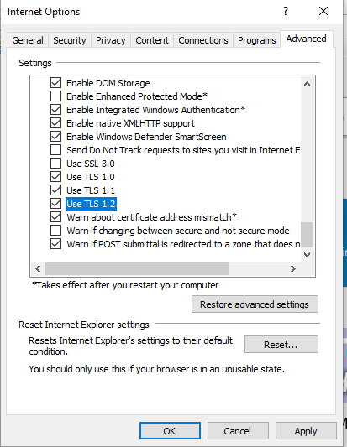

Scenario - Choppy Website Access Issues

Choppy Website Access Issues Like ARC, Client Websites, Reference websites
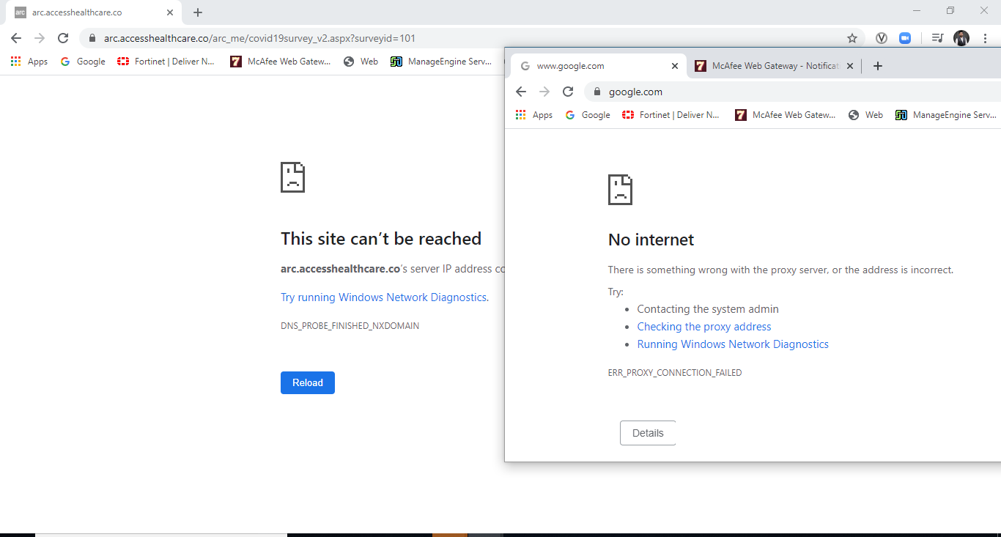

Fix to be provided

To Check the SSL-VPN connectivity, Open the Forticlient applicatio->REMOTE ACCESS.

Connection failure

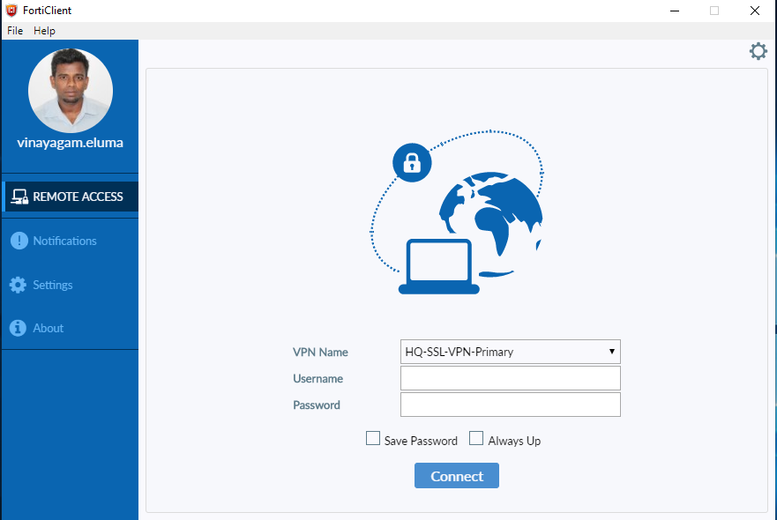

Fix to be provided
Reconnect the VPN Client with the windows NT credentials

Scenario - Desktop icons not loaded

Desktop icons not loaded after login
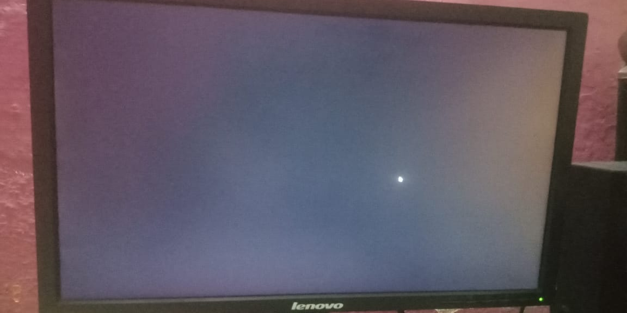

Fix to be provided
1. Login to User Profile and Open any one browser via search box.
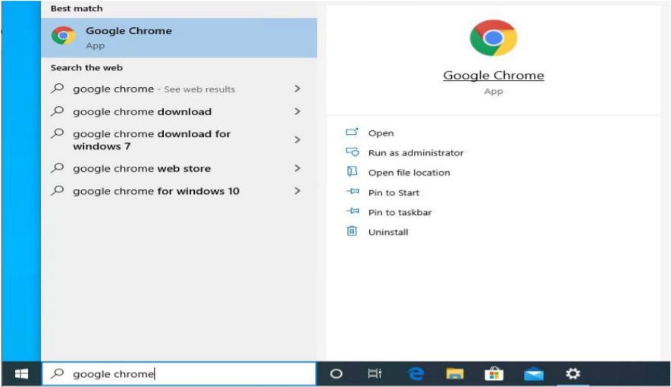

2. Use below mentioned our ahsfileshare link and click the Desktop Icons Button.
https://ahsfileshare.z30.web.core.windows.net/
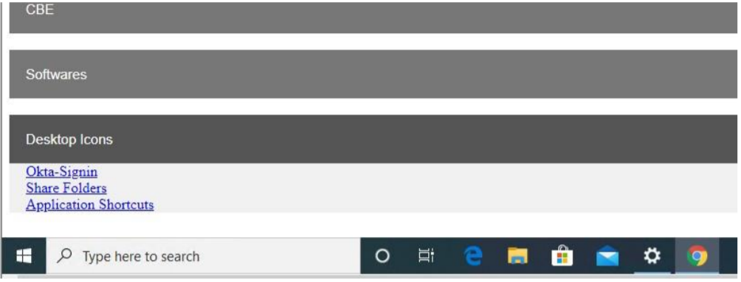
3.Click Share folder hyperlink. Share folder zip file will download Directly.
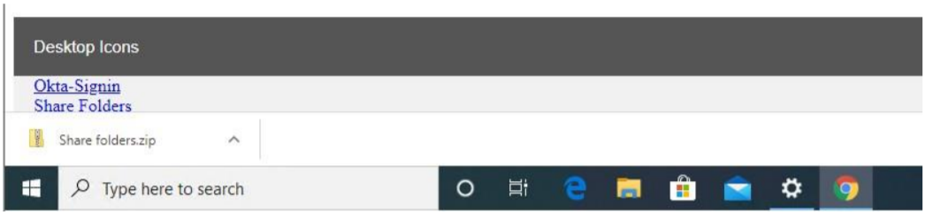

4.Open the share folders zip file. It will have all file server’s shortcut.
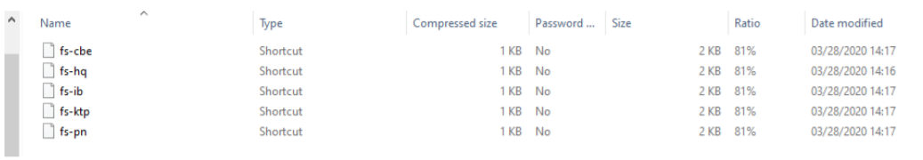

5. User can able open the required file server shortcut directly.
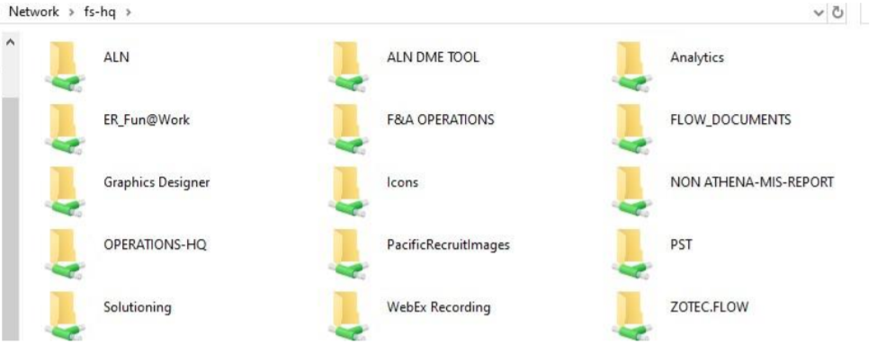

6. Similarly we have placed the Application shortcuts.
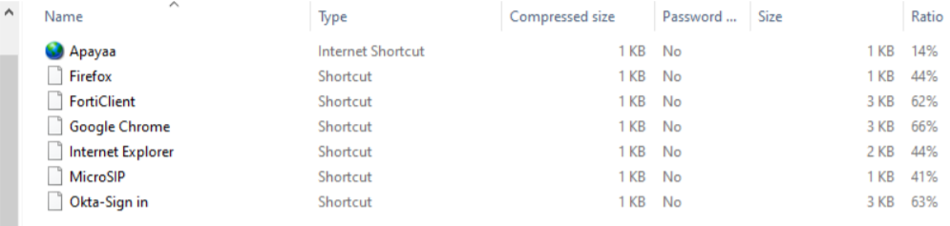

Scenario - File path not opening

File path not opening even using the desktop icon
If the shortcut in the desktop not working kindly use the fix provided below.

Fix to be provided
1.Go to file server and choose icon folder
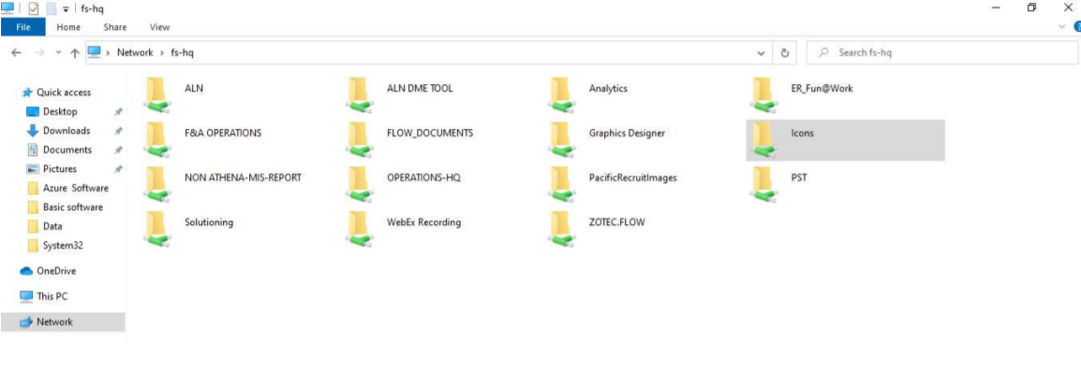
2.Click the fs-HQ icon (IP based icon)
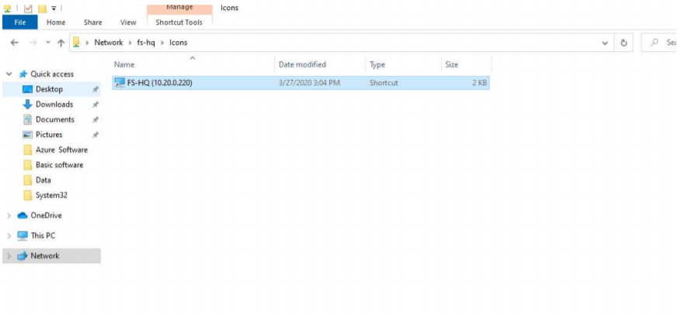
3. Share will appear and go to the required folder.

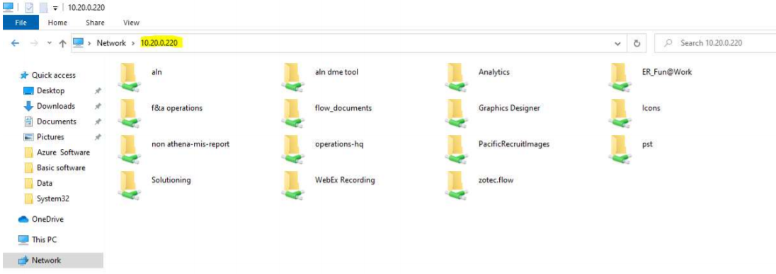

Scenario - Client application not working

Client application not working but arc is working
If you observe client applications or websites are not working but arc.accesshealthcare.co is working.

Fix to be provided
Go to the below setting in internet explorer and apply proxy automatic setting.
1.Open Internet Explorer -> Internet Options -> Connections-> LAN Settings -> Check use automatic configuration script’ Contact AHS-Infrasolutions Team(network@accesshealthcare.com).
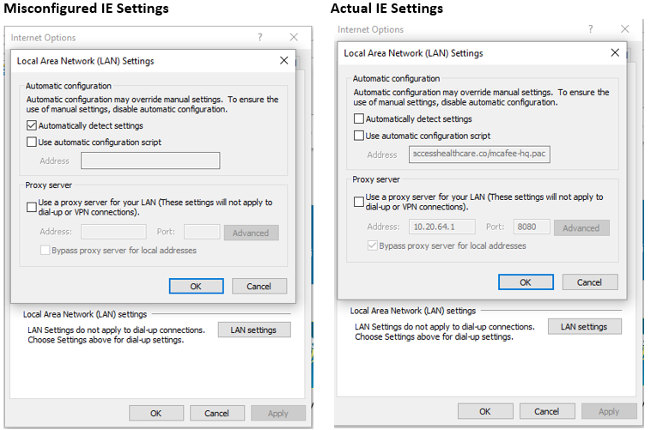

Scenario - Athena offline not working

Athena offline not working
If you observed that Athena offline is not working or exe had issues.

Fix to be provided
1. Login into Local admin user
2. Open the Chrome browser
3. Type the below URL https://ahsfileshare.z30.web.core.windows.net/
4. Click KO and choose Athena Offline and file will download
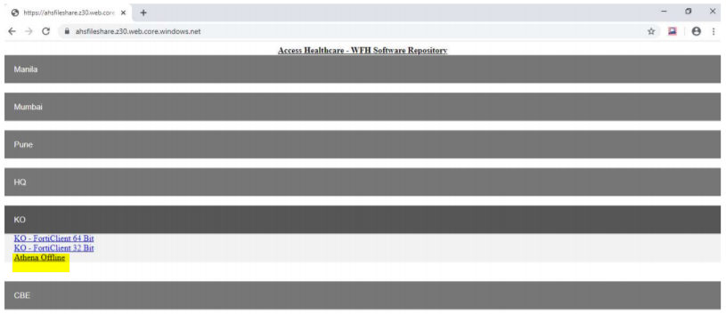
5. Go to Download folder
6. Right Click file and choose Extract All
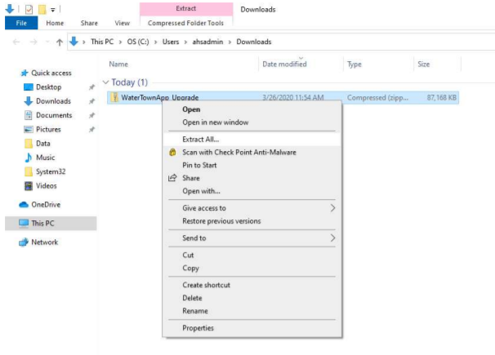

7. In Below window choose Extract
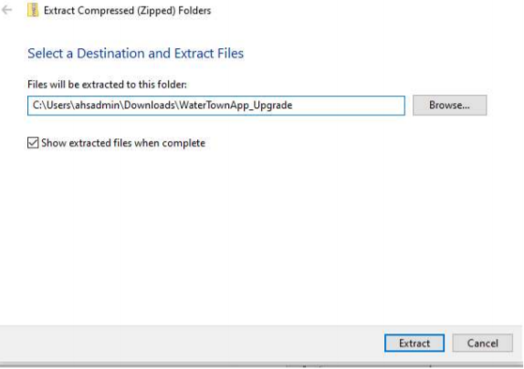

8. Below window appear and right click and Copy the folder
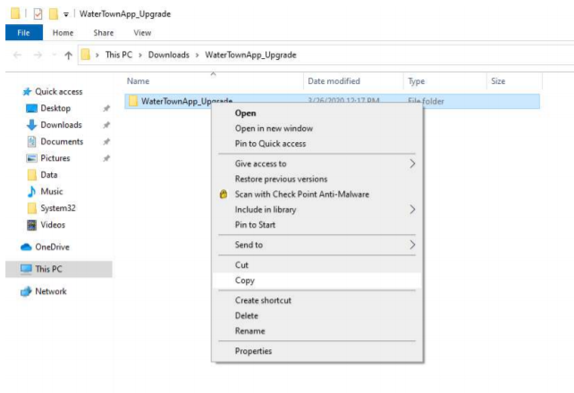
9. Go to C:\ drive and paste the folder
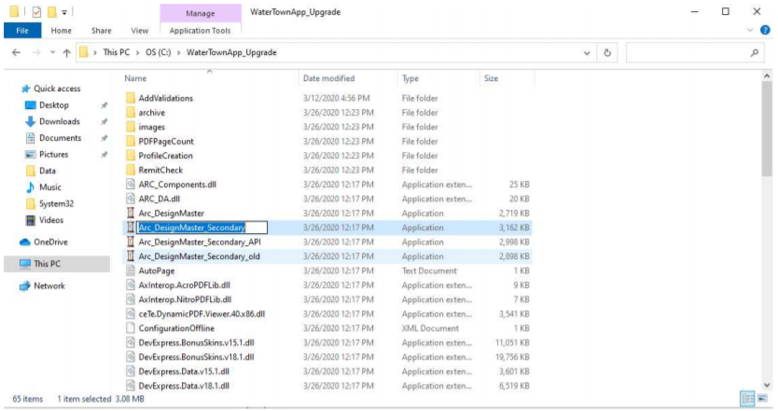

How to do Speed test

1.Install the Application ‘Speedtest by Ookla’ from the Google Play store
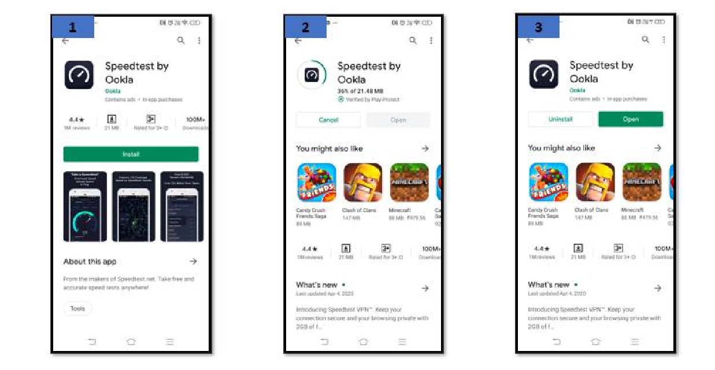
2.Basic Setup- Speedtest by Ookla

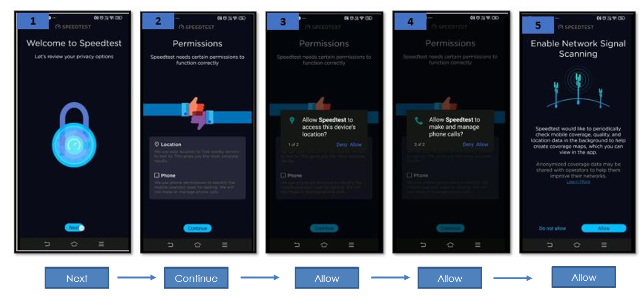

3.Click Dongle/Mobile Internet Speed Test in Ookla speedtest application
-Connect your mobile with your Dongle’s WiFi before starting the Speed test (The same method can be followed to test your Mobiles Internet Speed)
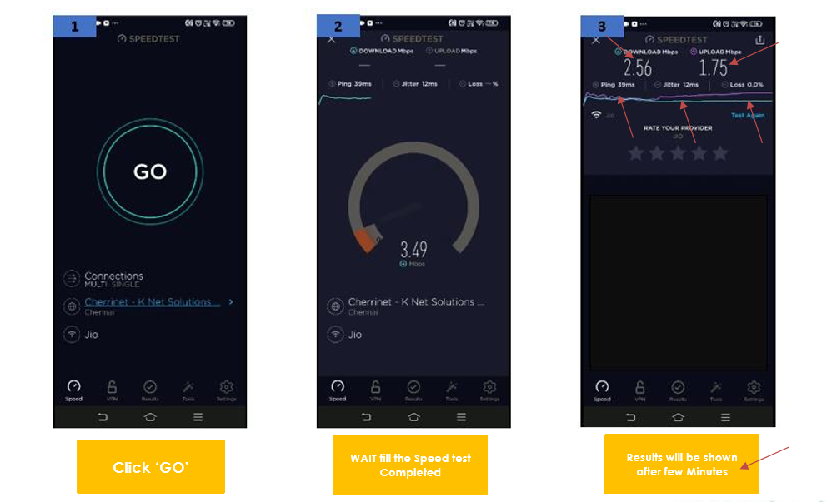
4.Include the mandatory Fields from the Speed test results during your Performance/ VPN Connectivity Issue Escalation
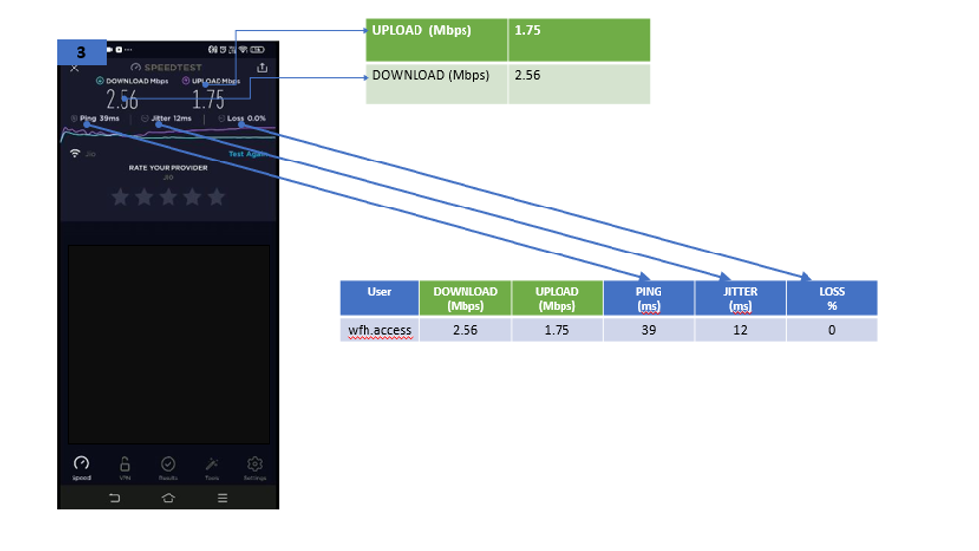

5.All the Speed Test Results will be saved in the ‘Results’ Page, Compare the Performance of your Dongle/ Mobile internet for future references.

